

**ARABICA VIET NAM TECHNOLOGY APPLICATION JOINT STOCK COMPANY**

DETAILED SERVICE FLOW

Table of Contents

1 FLOW OF SERVICE REGISTRATION 3

1.1 Via SMS 3

1.2 Via Website 4

2 FLOW OF BID 5

2.1 Admin create auction campaign 5

2.2 User bid via SMS 6

2.3 User bid via Website 7

3 FLOW OF WINNER CONFIRMATION & AWARD 8

4 USER JOURNEY 9

# FLOW OF SERVICE REGISTRATION

## Via SMS

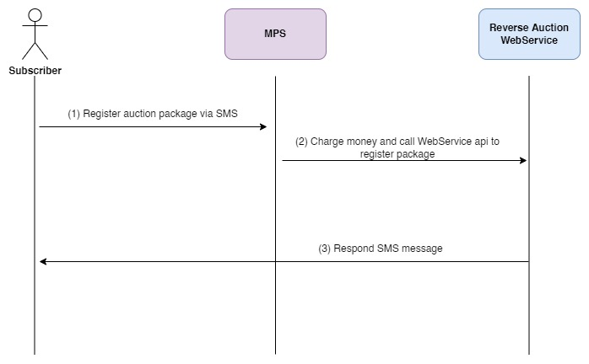

Step 1: Subscriber send register auction package to 23001

Step 2: MPS charges money if charge successfully then call Reverse Auction WebService api to register with Reverse Auction System

Step 3: Reverse Auction WebService send success SMS to subscriber

## Via Website

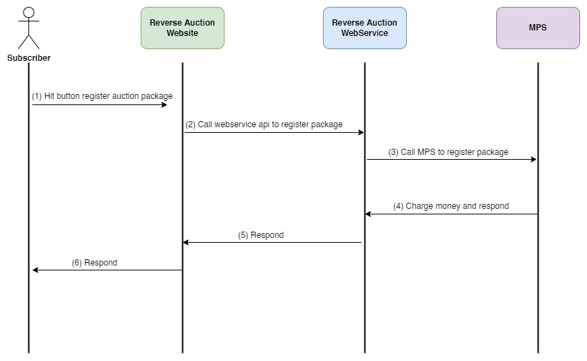

Step 1: After sign up to the website, user go to subsrcription page and choose package to register

Step 2: Website call WebService api to register auction package

Step 3: WebService will register auction package with MPS

Step 4: MPS charges money and respond success or fail to WebService due to charge successfully or not

Step 5: WebService responds to Website

Step 6: Website reponds to user

# FLOW OF BID

## Admin create auction campaign

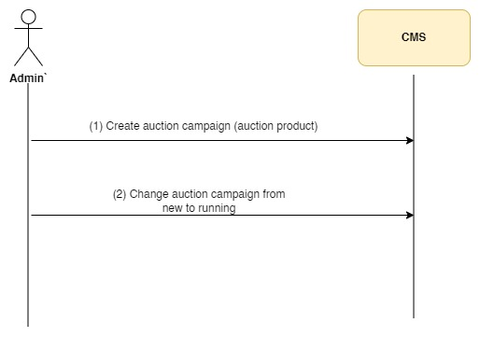

Step 1: Admin login to CMS and create auction campaign (auction product)

Step 2: Admin change status of campaign from new to running so that user can bid for this product

## User bid via SMS

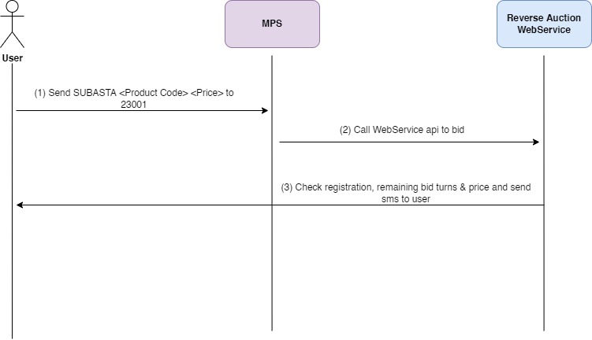

Step 1: User send bid message to 23001

Step 2: MPS call WebService api to bid

Step 3: Reverse Auction WebService will check the following conditions to send sms to user

If user has not registered reverse auction package then send SMS message saying that he needs to register service to bid

If user has registered but he has no remaining bid turn then send SMS message saying that he has no remaining bids and need to renew the package to continue to bid.

If user has remaining bid turns and the price is not lowest then send sorry SMS message saying that the price is not the lowest price to user.

If user has remaining bid turns and the price is lowest but duplicate then send sorry SMS message saying that the price is lowest but duplicate to user. And also send a SMS to the user that is holding the advantage saying that he looses the advantage.

If user has remaining bid turns and the price is lowest and unique then send congratulations&goodluck SMS message to user. And also send a SMS to the user that is holding the advantage saying that he looses the advantage.

## User bid via Website

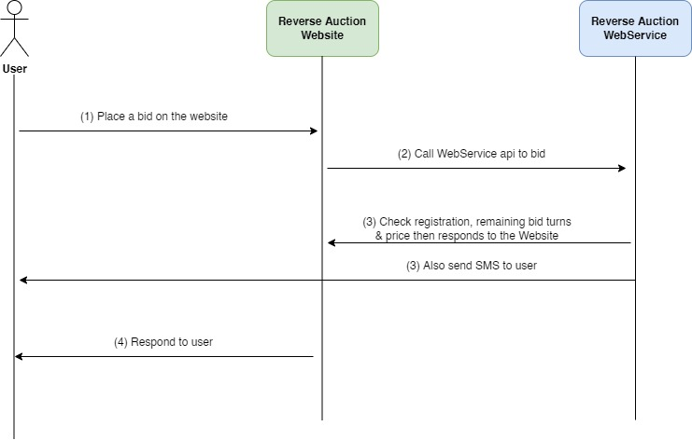

Step 1: User login to website and place a bid for a product

Step 2: The website calls WebService api to bid

Step 3: Reverse Auction WebService will the following conditions to respond to the user

If user has not registered reverse auction package then send SMS message saying that he needs to register service to bid

If user has registered but he has no remaining bid turn then send SMS message saying that he has no remaining bids and need to renew the package to continue to bid.

If user has remaining bid turns and the price is not lowest then respond to the website & send sorry SMS message saying that the price is not the lowest price to user.

If user has remaining bid turns and the price is lowest but duplicate then respond to the website & send sorry SMS message saying that the price is lowest but duplicate to user. And also send a SMS to the user that is holding the advantage saying that he looses the advantage.

If user has remaining bid turns and the price is lowest and unique then respond to the website & send congratulations & good luck SMS message to user. And also send a SMS to the user that is holding the advantage saying that he looses the advantage.

Step 4: Website responds to user

# FLOW OF WINNER CONFIRMATION & AWARD

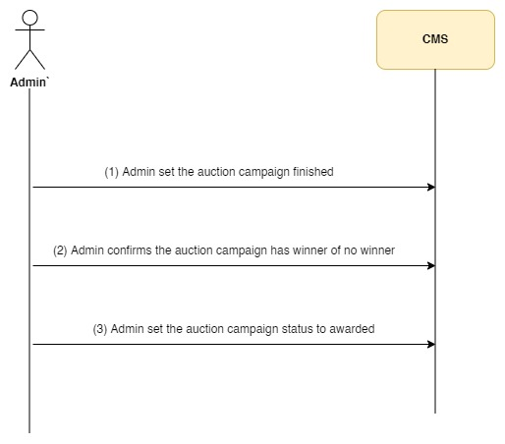

Step 1: When the auction period ends, admin login to CMS and set the auction campaign status to finished.

Step 2: Admin confirms the auction campaign has a winner or no winner

If there is an unique and lowest bidding price then there is a winner for campaign

If there are many duplicate lowest price then there is no winner for campaign

After confirm the winner for the auction campaign, Bitel will contact with the winner and award him.

Step 3: After awarded the winner, admin go to CMS and set auction campaign status to awarded.

# USER JOURNEY

Step 1: User sign up to the Reverse Auction Website

Step 2: User login to Reverse Auction Website and register reverse auction package (daily, weekly or monthly).

Step 3: User choose product to bid.

Step 4: User continues to bid if the price is not lowest.

Step 5: When the auction period ends, admin login to CMS and set the auction campaign (product) status to finished.

Step 6: Admin go to CMS to confirm the winner for the auction campaign (product).

Step 7: Bitel contact to the winner to award him.

Step 8. Admin go to CMS to set status of the auction campaign to awarded.